**DSA Experiment - 6**

HARSHIT SARASWAT | B-42 | 500097101

**Question 1 :** Implement a Hash table using arrays (dynamic array) and Linear probing as a Collision avoidance strategy. Perform Insert, Delete and Search operations on the Hash table using the above Hash function.

**Code :**

#include <stdio.h>

#include <stdlib.h>

int * hash_array;

int count = 0;

int size;

int hash_function(int hash_key);

int add_till_death(int input);

int main()

{

printf("\t\t\t\tLinear Probing DSA Experiment - 6");

//printf("Enter Size of Hash Table Array : ");

//scanf("%d",&size);

size = 10;

hash_array = (int *)malloc(size*sizeof(int));

for(int i = 0;i < size;i++){

hash_array[i] = NULL;

}

int choice = 0;

while (1 == 1){

printf("\n1 - To Enter Sap ID\n2 - To Delete SAP_ID\n3 - Find Hash Key\n4 - Quit\nChoice : ");

scanf("%d",&choice);

switch(choice){

case 1 : insert_key_to_table();break;

case 2 : delete_key();break;

case 3 : search_key();break;

case 4 : exit(0);

}

printf("\n");

}

return 0;

}

int hash_function(int hash_key){ //RETURN THE ARRAY INDEX FOR THE GIVEN KEY - IN THIS CASE SAP ID

hash_key = hash_key - 5000000;

return add_till_death(hash_key);

}

void insert_key_to_table(){ //FRONT END PRETTY FUNCTION

int data = 0;

printf("Enter SAP_ID To insert : ");

scanf("%d",&data);

insert_to_array_hash_table(data,hash_function(data));

}

int insert_to_array_hash_table(int data,int key){ //TECHNICAL FUNCTION BACKEND

if (hash_array[key] == NULL){

hash_array[key] = data;

return;

}

//LINEAR PROBING

int i = 0;

for(i = (key + 1) % size; hash_array[i]!=NULL && i!=key ; i++,i = i % size); //KEEP GOING TO INDEX THAT IS NULL EVEN AFTER END OF ARRAY

if (i == key){

printf("\nNo Available Space Array is FULL...");

return;

}

hash_array[i] = data;

}

int add_till_death(int input){

int total = 0;

while (input != 0){

total = total + input % 10;

input = input/10;

}

if (total > 9)

total = add_till_death(total);

return total;

}

void search_key(){

int data;

int key_index;

printf("Enter Entry to Find : ");

scanf("%d", &data);

key_index = hash_function(data);

if (hash_array[key_index] == data){ //TO MAKE THE FOR LOOP CONDITION USEABLE

printf("\n%d is Present at Index : %d",data,key_index);

return;

}

int i = key_index+1;

for (i ; hash_array[i] != data && i!=key_index ; i++,i = i % size);

if (i == key_index){

printf("\nKey not in Table");

return;

}

printf("\n%d is Present at Index : %d",data,i);

}

void delete_key(){

int data;

printf("\nEnter Key to Delete : ");

scanf("%d",&data);

int key_index = hash_function(data);

int i = key_index + 1;

if (hash_array[key_index] == data){

printf("\nDeleted Key : %d",hash_array[key_index]);

hash_array[key_index] = NULL;

return;

}

for (i ; hash_array[i] != data && i!= key_index; i++,i = i % size);

if (i == key_index){

printf("\nKey not in Table\n");

return;

}

printf("\nDeleted Key : %d",hash_array[i]);

hash_array[i] = NULL;

}

Output :

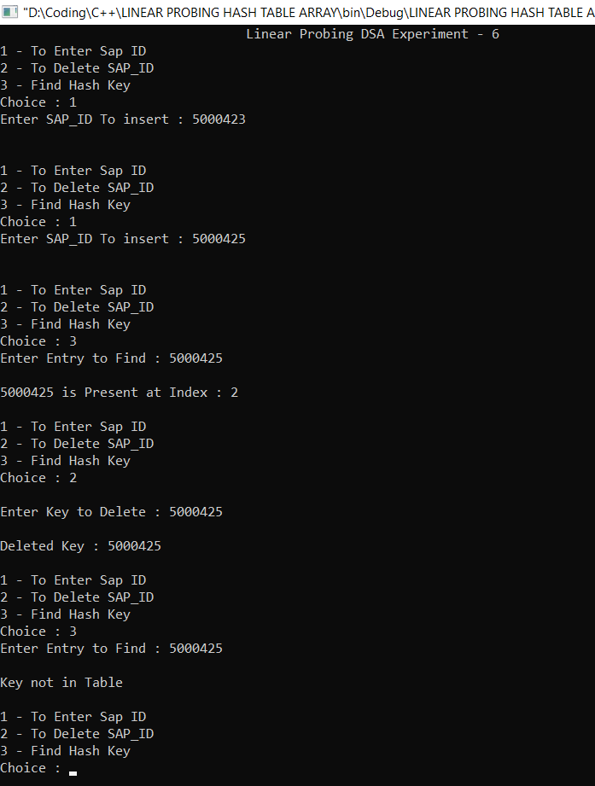

**Question 2 :** Implement a Hash table using arrays (dynamic array) and Linear probing as a Collision avoidance strategy. Perform Insert, Delete and Search operations on the Hash table using the above Hash function. Compute Load Factor (LF). When LF>50% apply rehashing (with a new dynamic array size & suitable hash function).

**Code :**

#include <stdio.h>

#include <stdlib.h>

int * hash_array;

int count = 0;

int size;

int hash_function(int hash_key);

int add_till_death(int input);

int main(){

printf("\t\t\t\tLinear Probing DSA Experiment - 6");

//printf("Enter Size of Hash Table Array : ");

//scanf("%d",&size);

size = 10;

hash_array = (int *)malloc(size*sizeof(int));

for(int i = 0;i < size;i++){

hash_array[i] = NULL;

}

int choice = 0;

while (1 == 1){

printf("\n1 - To Enter Sap ID\n2 - To Delete SAP_ID\n3 - Find Hash Key\n4 - Quit\nChoice : ");

scanf("%d",&choice);

switch(choice){

case 1 : insert_key_to_table(hash_array);rehashing();break;

case 2 : delete_key();break;

case 3 : search_key();break;

case 4 : exit(0);

}

printf("\n");

}

return 0;

}

void rehashing(){

float load_factor = (float)count/size;

if (load_factor < 0.5){

printf("No Need For Rehashing Load Factor = %.2f\n",load_factor);

return;

}

printf("LOAD FACTOR OVER 0.5... REHASHING...\n");

count = 0;

int * new_hash_array = (int *)malloc((size*2)*sizeof(int));

int old_size = size;

size = size*2;

for (int i = 0; i < size*2; i++){

new_hash_array[i] = NULL;

}

for (int i = 0 ; i < old_size; i++){

if (hash_array[i] == NULL)

continue;

int data = hash_array[i];

insert_to_array_hash_table(data,hash_function(data),new_hash_array);

}

hash_array = new_hash_array;

printf("\nNew Hash Array\n");

for (int i = 0; i < size;i++){

printf("| %d |",hash_array[i]);

}

}

int hash_function(int hash_key){ //RETURN THE ARRAY INDEX FOR THE GIVEN KEY - IN THIS CASE SAP ID

hash_key = hash_key - 5000000;

return add_till_death(hash_key);

}

void insert_key_to_table(int * hash_array){ //FRONT END PRETTY FUNCTION

int data = 0;

printf("Enter SAP_ID To insert : ");

scanf("%d",&data);

insert_to_array_hash_table(data,hash_function(data),hash_array);

}

int insert_to_array_hash_table(int data,int key,int * hash_array){ //TECHNICAL FUNCTION BACKEND

if (hash_array[key] == NULL){

count++;

hash_array[key] = data;

return;

}

//LINEAR PROBING

int i = 0;

for(i = (key + 1) % size; hash_array[i]!=NULL && i!=key ; i++,i = i % size); //KEEP GOING TO INDEX THAT IS NULL EVEN AFTER END OF ARRAY

if (i == key){

printf("\nNo Available Space Array is FULL...");

return;

}

count++;

hash_array[i] = data;

}

int add_till_death(int input){

int total = 0;

while (input != 0){

total = total + input % 10;

input = input/10;

}

if (total > 9)

total = add_till_death(total);

return total;

}

void search_key(){

int data;

int key_index;

printf("Enter Entry to Find : ");

scanf("%d", &data);

key_index = hash_function(data);

if (hash_array[key_index] == data){ //TO MAKE THE FOR LOOP CONDITION USEABLE

printf("\n%d is Present at Index : %d",data,key_index);

return;

}

int i = key_index+1;

for (i ; hash_array[i] != data && i!=key_index ; i++,i = i % size);

if (i == key_index){

printf("\nKey not in Table");

return;

}

printf("\n%d is Present at Index : %d",data,i);

}

void delete_key(){

int data;

printf("\nEnter Key to Delete : ");

scanf("%d",&data);

int key_index = hash_function(data);

int i = key_index + 1;

if (hash_array[key_index] == data){

printf("\nDeleted Key : %d",hash_array[key_index]);

hash_array[key_index] = NULL;

return;

}

for (i ; hash_array[i] != data && i!= key_index; i++,i = i % size);

if (i == key_index){

printf("\nKey not in Table\n");

return;

}

printf("\nDeleted Key : %d",hash_array[i]);

hash_array[i] = NULL;

}

**Output :**

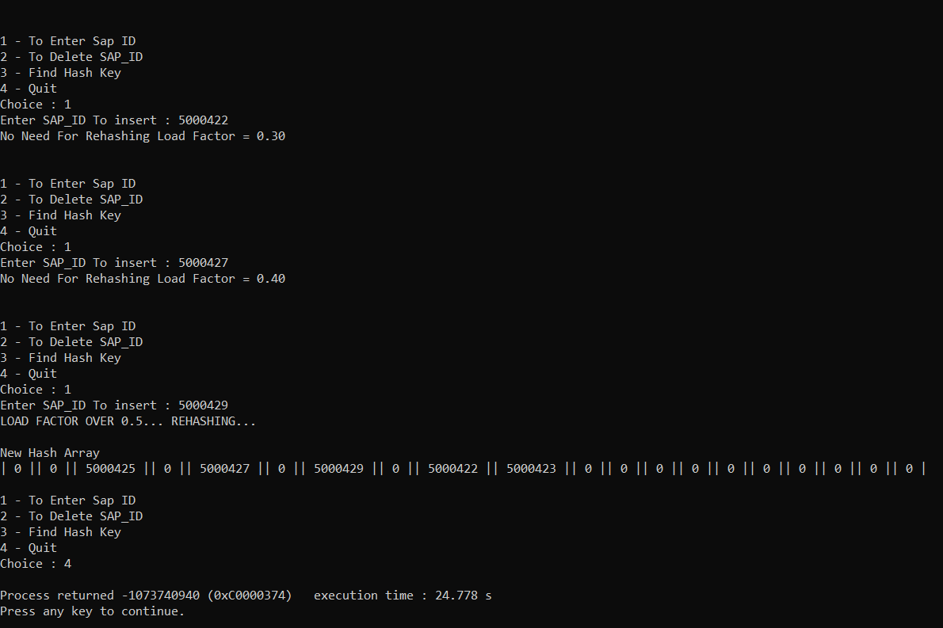

**Question 3 :** Implement a Hash table using an array of Linked Lists with a Separate Chaining Collision avoidance strategy. Perform Insert, Delete and Search operations on the hash table using a suitable Hash function.

**Code :**

#include <stdio.h>

#include <stdlib.h>

struct node {

int Sap_id;

struct node * next;

};

struct node * ptr;

struct node * new_sap;

struct node * array_of_linked_list [10];

int sap_hash_function(int sap_id);

int add_of_all_digits(int input);

int main(){

for (int i = 0; i < 10; i++){ //INITIALIZE ALL ARRAY POINTERS TO NULL

array_of_linked_list[i] = NULL;

}

int repeat = 1;

while(repeat == 1){

printf("1 - Add a Sap to The Hash Table\n2 - Print The Hash Table\n3 - Quit\nChoice : ");

scanf("%d",&repeat);

switch(repeat){

case 1 : take_sap_and_place_position();

break;

case 2 : print_hash_table();

break;

case 3 : return 0;

}

repeat = 1;

}

return 0;

}

//SAP TAKER

int take_sap_and_place_position(){

int input_sap_id = 0;

int hashed_index = 0;

printf("Enter Your SAP ID : ");

scanf("%d",&input_sap_id);

hashed_index = sap_hash_function(input_sap_id);

place_in_array(hashed_index,input_sap_id);

}

void print_hash_table(){

for (int hash_key = 0;hash_key < 10; hash_key++){

ptr = array_of_linked_list[hash_key];

printf("HASH KEY : %d",hash_key);

for (ptr; ptr!=NULL; ptr = ptr->next)

printf(" SAP : %d ",ptr->Sap_id);

printf("\n");

}

}

void place_in_array(int hash_key, int sap_id){

if (array_of_linked_list[hash_key] != NULL){ //INSERT AT START IF NOT NULL

new_sap = (struct node *)malloc(sizeof(struct node));

new_sap->next = array_of_linked_list[hash_key];

new_sap->Sap_id = sap_id;

array_of_linked_list[hash_key] = new_sap;

return;

}

new_sap = (struct node *)malloc(sizeof(struct node));

new_sap->next = NULL;

new_sap->Sap_id = sap_id;

array_of_linked_list[hash_key] = new_sap;

}

//THE HASH function

int sap_hash_function(int sap_id){

int hashed_index = 0;

int temp_sap = sap_id;

temp_sap = sap_id - 5000000;

hashed_index = add_of_all_digits(temp_sap);

while (hashed_index > 9){

hashed_index = add_of_all_digits(hashed_index);

}

return hashed_index;

}

int add_of_all_digits(int input){

int added = 0;

while(input != 0){

added = added + input%10;

input = input/10;

}

return added;

}

**Output :**

